DEPARTMENT OF ECONOMICS JESUS AND MARY COLLEGE OVERVIEW 2021-22

# ENGAGING WITH ALUMNAE

* DATE: 18th August, 2021
* TIME : 1-2pm
* PLATFORM USED: MS Teams
* TOTAL ATTENDEES: 72

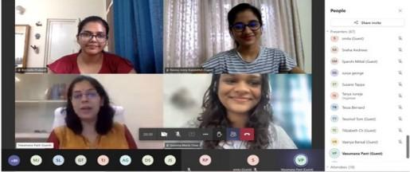

On August 18, 2021, the Department of Economics at JMC hosted an online webinar titled "Civil Services as a Career Option" featuring Ms. Vasumana Pant, an alumna and IAS ofﬁcer. Ms. Pant discussed the beneﬁts of civil services compared to corporate jobs, emphasizing social impact, personal growth, and job security.

She highlighted the importance of women in government roles and advised students to explore their career options. The session concluded with a Q&A session and a vote of thanks from the Vice-president.

# **Contrarian : workshop**

DATE: 23rd August, 2021

* PLATFORM USED: Google meet
* TOTAL ATTENDEES: 43

The Contrarian Economics Magazine launched a Workshop Series on Academic Research Writing, starting with its first session on August 23, 2021. The session was led by Ms. Annapurna Mitra, an Economist at the International Monetary Fund with a PhD in International Economics from the Graduate Institute of International and Development Studies, Geneva.

Ms. Mitra's masterclass on academic research writing was comprehensive and engaging. She emphasized the critical role of data sets and the integration of existing research and policies in crafting research papers for policy research or policy makers. She highlighted the importance of understanding both the current state and the implications of proposed research.

Additionally, Ms. Mitra advised undergraduates on preparing for careers in Economic Policy and Research, urging them to actively read research materials and leverage virtual platforms for professional development. She stressed the value of creating data-driven narratives, using infographics to compare economic aspects across different times and places.

During the interactive Q&A session, participants and Ms. Mitra discussed strategies for tackling complex topics in research papers and addressed issues related to plagiarism, including how to avoid self-plagiarism. The session concluded with a brainstorming activity, ensuring attendees left with practical insights and inspiration for their future research endeavors.

# Teachers' Day Celebration

Date:4th September 2021

Time: 4:30 PM - 5:30

Platform Used: Google Meet Total Attendees: 54

On 4th September 2021, the Department of Economics, Jesus and Mary College, organized a virtual Teachers' Day celebration to honor the dedication and efforts of the teachers.The event began with a warm welcome by President Rochelle, followed by a special pre-recorded dance performance by the students. Sandra Sam presented her self-written poem, "Everyday Over and Over," highlighting the vital role of teachers. Personalized e-cards with messages from the students were shared with the teachers, followed by a melodious song rendition

A fun "Guess the Song" game was held where teachers guessed Hindi songs from their English translations. Alisha Ma’am performed "Arms" by Christina Perri, and the event concluded with a piano performance by student Sara Bhasin.

Vice President Gemma thanked the teachers and participants, and Smita Ma’am gave a heartwarming speech to conclude the celebration.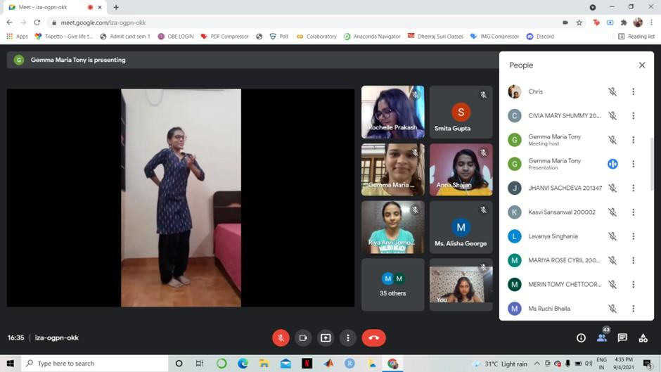

# Challenges Faced by Women and Girls During the COVID Pandemic

Date:8th September 2021, Wednesday Time: 1:00 PM - 2:00 PM

Platform: Google Meet Total Attendees: 48

The Department of Economics, Jesus and Mary College, hosted a webinar featuring Dr. Aruna Broota, a retired Professor of Psychology from the University of Delhi, who spoke on the challenges faced by women and girls during the COVID pandemic.

The webinar began with a presidential address by Rochelle Prakash, followed by a welcome from Ms. Smita Gupta, the teacher in charge of the department. Dr.Broota discussed the severe impact of the pandemic on mental health highlighting the increased vulnerability and anxiety,

among people, especially women, due to social restrictions and obligations. She suggested measures such as talking with parents or friends to maintain mental well-being.

The session included a Q&A moderated by Muskkaan Khanna, where attendees asked about gender differences, domestic violence, and coping with online classes. The event concluded with a vote of thanks by Vice President Gemma Maria Tony, and Dr. Broota was presented with a digital portrait made by a student of the department.



# **Contrarian session**

* + DATE: 10th September, 2021
  + PLATFORM USED: Google meet
  + TOTAL ATTENDEES: 37

The Contrarian Reading's first discussion of the 2021-22 session delved into the theme of "Capitalism and Gender," examining the works of scholars like Jayati Ghosh, Ann E. Cudd, Tithi Bhattacharya, and Dalia Gebrial. The discussion focused on the invisibilization of women in economic processes driven by capitalism. It highlighted issues such as tokenism in corporate campaigns, the pink tax, and the systemic devaluation of women's labor. Members explored how capitalism and patriarchy intersect to perpetuate gender inequality, affecting women's access to fair wages, working conditions, and recognition in both domestic and global economies. They also debated the contrasting impacts of capitalism and socialism on women's liberation, with many leaning towards socialism's potential for greater equality. The session concluded with a call for proactive policy interventions to translate gender-inclusive rhetoric into tangible improvements for women across all socioeconomic strata.

# **Workshop series**

* DATE: 13th September, 2021
* PLATFORM USED: Google meet
* TOTAL ATTENDEES: 43

The Contrarian's Workshop Series on Academic Research Writing continued with its second lecture on September 13, 2021, featuring Dr. Dweepobotee Brahma from the Centre for Mathematical and Computational Economics. Dr. Brahma emphasized the essentials of academic writing, including clarity in research questions, meticulous data description, and the significance of a well-crafted conclusion. She also highlighted the importance of editing and advised students on effective writing practices, concluding with insights on overcoming writer's block. The session concluded with a Vote of Thanks from Riya Gangwal, Editor-in-Chief of The Contrarian.

# **Webinar: Impact of the COVID-19 Pandemic on the Indian Economy and the Road to Recovery**

Date: 22nd September 2021 Time: 1:00 PM - 2:00 PM

Venue: Google meet Total Attendees:76

The Department of Economics, Jesus and Mary College, organized an interactive webinar with Professor Arun Kumar, Malcolm Adiseshiah Chair Professor at the Institute of Social Sciences, on the topic "Impact of the COVID-19 Pandemic on the Indian Economy and the Road to Recovery."

The event began with an address by Ms. Smita, followed by a formal welcome by Rochelle. Professor Kumar provided insights into the causes of the second wave of COVID-19, the importance of genome testing, and the risks associated with virus mutations. He discussed the nationwide lockdown's impact on the economy, inaccuracies in GDP data due to the pandemic, and the resulting unemployment.

Professor Kumar also touched on the ethical aspects of the pandemic, emphasizing the need for social justice. The webinar concluded with a Q&A session where the speaker addressed questions from students. Vice President Gemma Maria Tony proposed a vote of thanks to conclude the event.

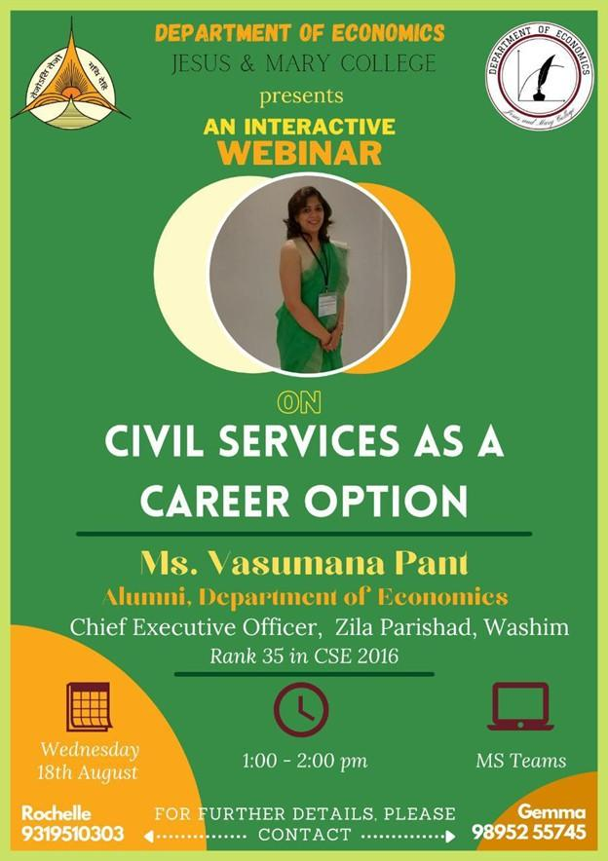

# **ALUMNAE MEET 2021**

Date:25th September 2021, Saturday Time: 4:00 PM - 5:45 PM

Platform: Google Meet Total Attendees:60+

The Department of Economics, Jesus and Mary College, hosted its 3rd Alumnae Meet with 36 alumni, including Ms. Ela Trivedi, reminiscing about college days. The event began with a presidential address by Ms. Rochelle Prakash, followed by Ms. Smita Gupta's welcome.

The program included a welcome song, alumni introductions by Ms. Akanksha Aggarwal, Ms. Ella Trivedi’s address, a piano performance by Ms. Sara Bhasin, and further alumni introductions by Ms. Jasmin and Ms. Ruchi Bhalla. The session concluded with a dance performance and games like "Guess the Music" and Tambola, with prizes for winners. The meet ended with a vote of thanks by Vice President Gemma Maria Tony.

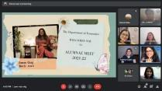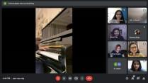

# **Report: Screening + Discussion on War Economy: Afghanistan in Perspective**

Date:1st October 2021 Platform Used: Google Meet Total Attendees:36

The Contrarian Economics Magazine, JMC, organized an interactive short ﬁlm screening themed "War Economy: Afghanistan in Perspective," exploring the impacts of war and instability on Afghan civilians. The ﬁlm, titled "How the 20-year war changed Afghanistan," highlighted the experiences and tragedies faced by the Afghan people.

The screening was followed by a presentation analyzing the socio-economic situation of Afghanistan, discussing issues such as poor economic growth, weak institutions, and the terror of war. Members shared views on the severe impact on women's and children's rights and the global normalization of the war in Afghanistan. The discussion emphasized the necessity of focusing on education and healthcare for women and children as immediate goals. The power of social media in inﬂuencing policy decisions was also highlighted. Members concluded that the global community needs to be more receptive to the needs of civilians in

war zones, echoing Martin Luther King Jr.'s sentiment that “Injustice anywhere is a threat to justice everywhere.”

# **Academic Research Writing Workshop**

* DATE: 22nd October, 2021
* PLATFORM USED: Google meet
* TOTAL ATTENDEES: 37

The Contrarian Economics Magazine initiated a Workshop Series on Academic Research Writing, with the third session held on October 22, 2021. Mr. Sridhar Halali, an evolutionary ecologist and postdoc researcher from the University of Helsinki, led the session focusing on data visualization techniques. Beginning with an assessment of attendees' familiarity with statistical software, Mr. Sridhar underscored the importance of moving beyond traditional data representation methods like bar plots. He introduced alternative visualizations such as Lollipop graphs, Violin plots, Dot plots, and others, emphasizing their advantages and aesthetic appeal. He also discussed hybrid plots that combine different types for enhanced data communication. The session concluded with an interactive Q&A and resource sharing for further learning on data presentation techniques.

# **Chankaya webinar**

Date: 25th February 2022, Friday Time:5:45 PM - 7:00 PM

Platform: Google Meet Total Attendees: 100

Chanakya, The Economics Cell, successfully conducted its ﬁrst-ever webinar on “Almost Everything You Need to Know About Plagiarism but Were Afraid to Ask” by Prof. Nandan Nawn.

The event began with a presidential address by Kavya Tandon and a welcome by Ms. Smita Gupta, the teacher in charge of the Department of Economics. Prof.Nawn explained the meaning of plagiarism, how to avoid it, and its signiﬁcance in academic writing. He emphasized the need for proper citation, the art of paraphrasing, and the importance of academic integrity. An interactive Q&A session followed, where attendees discuused the implications of plagiarism and ways to avoid self-plagiarism. The webinar concluded with a vote of thanks by Rochelle Prakash, the President of the Economics Department